Week 3 - Login Tokens & The Login Page

Objective:
In this week, my task is to check the logout and session behavior in the Phoenix project. The purpose of the test is to check if logging out actually ends the user session and whether the old token can be used.

Session results:
Test | Expacted | Acutal | Result
Accses token after logout | Token should be rejected | 401 logged out Pass out | Pass
Refresh token after logout | Token should be rejected | 401 invalid refresh token | Pass
Expried accses token | Token should be rejected after 15 mintues | 401 invaled token | Pass

Testing processes:

First, I logged into the application using a valid username and password. The login was successful, and the provided user has access and refresh tokens.

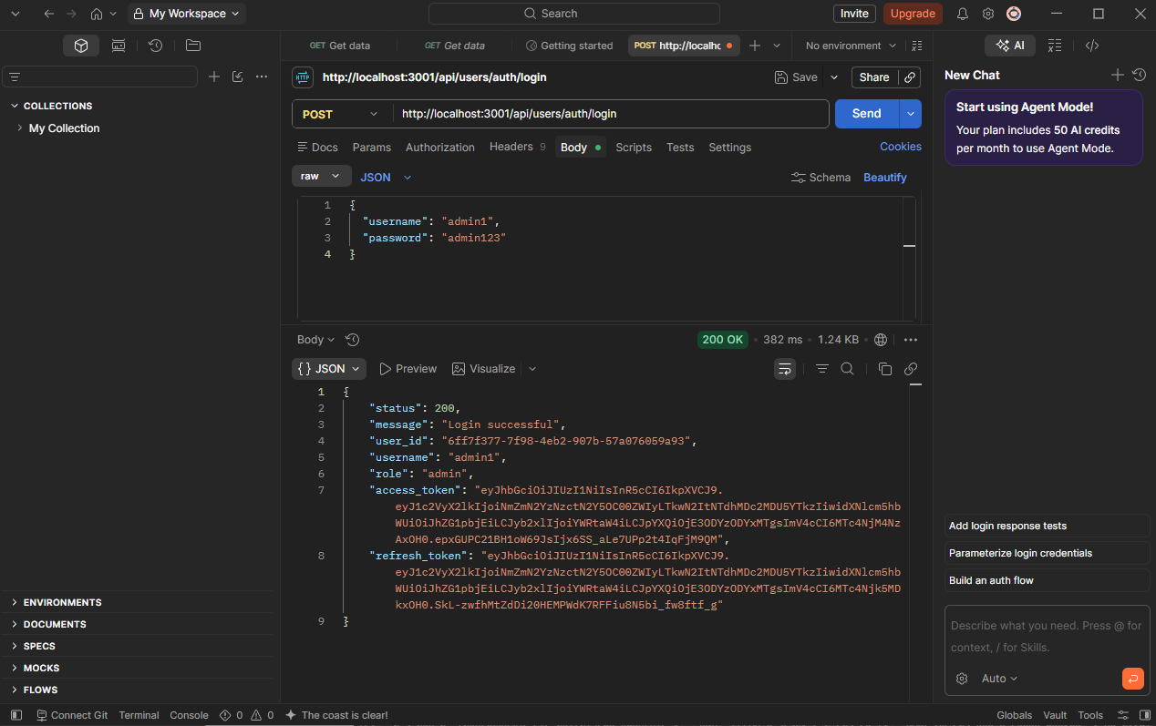

Then, the access token was to access the /api/users/threats endpoint; the request successfully uploaded the page. This confirms the token is valid while the user is logged in.
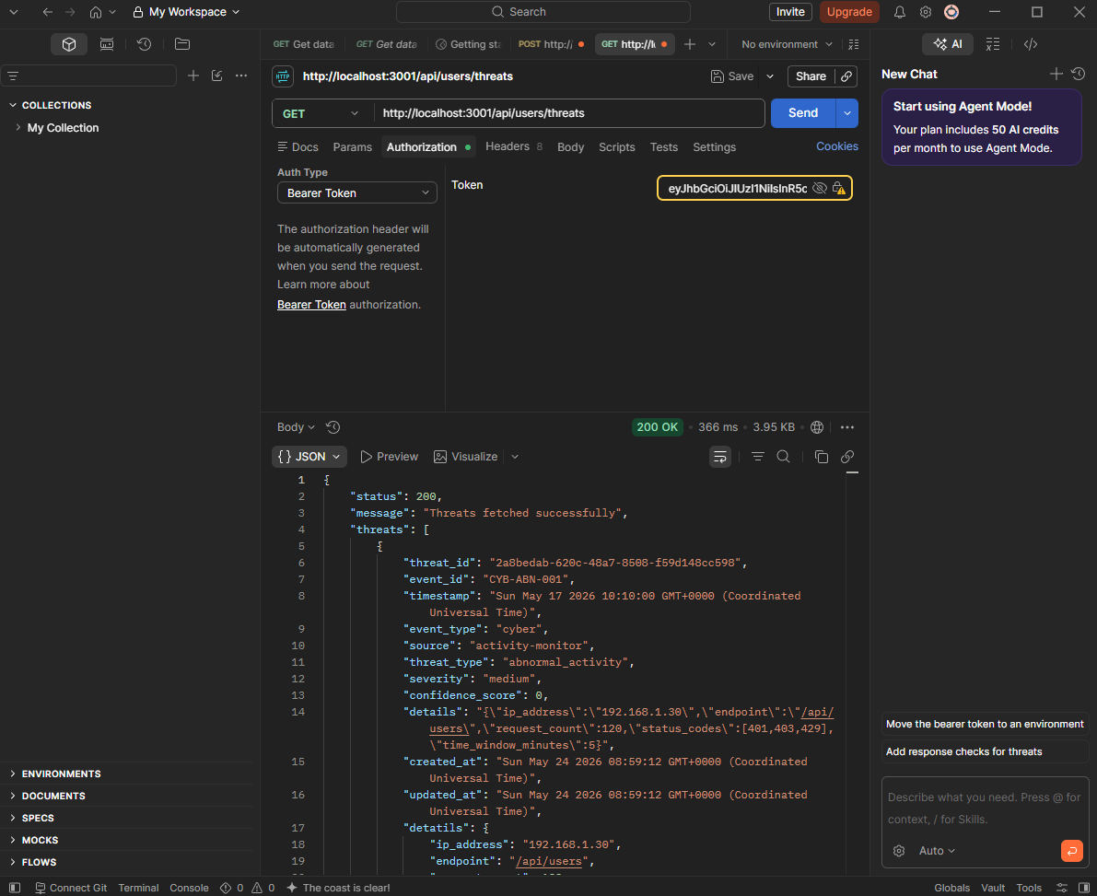

After that, I logged out using the user ID with the same access token; the request resulted in 200 ok with the message “logged out successfully.”
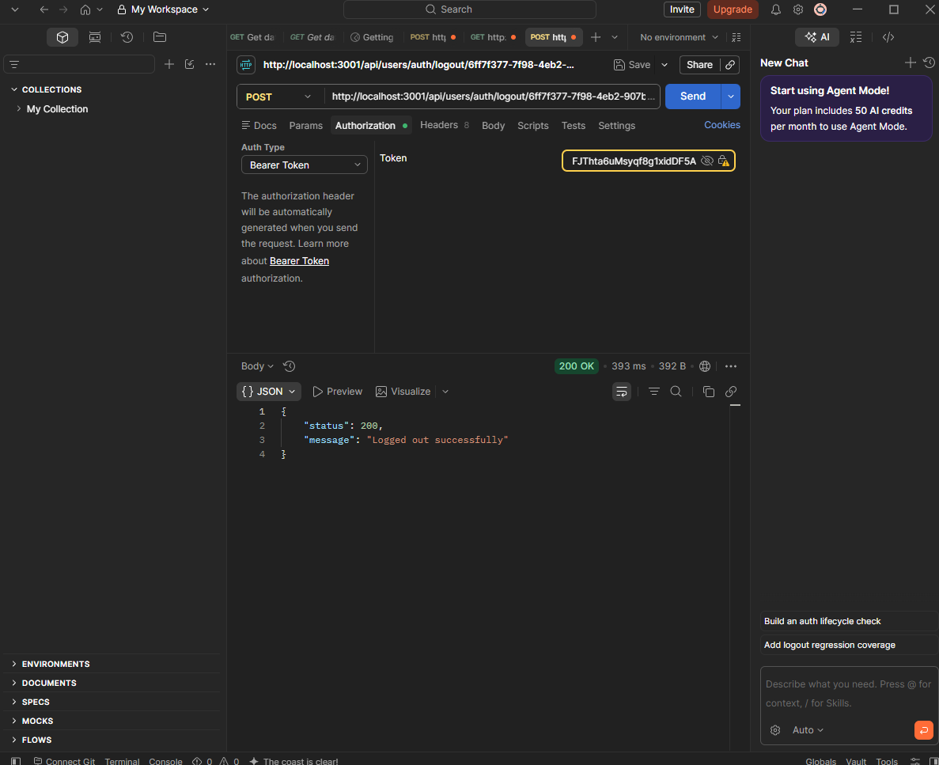

After logging out, I tried to access the /api/users/threats endpoint again with the access token. It’s time the server returns a 401 status with the message “logged out.” This shows that an old access token could not be reused after logout.
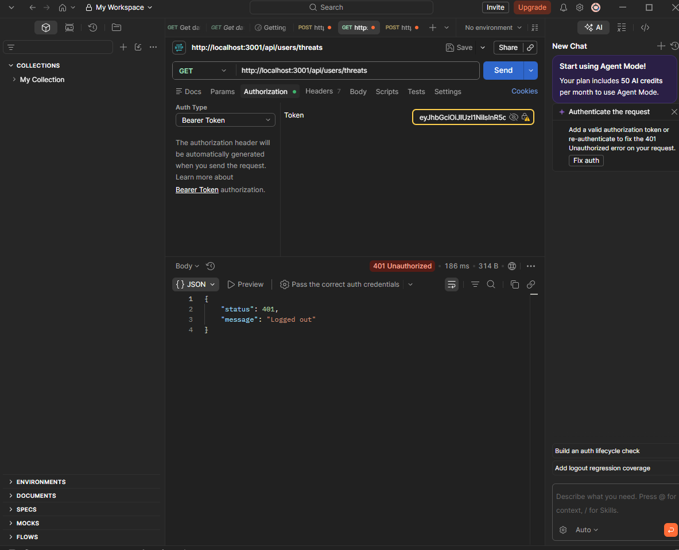

I also tested whether an expired access token would still be accepted after 15 minutes, which is the configured time for its expiration date. After logging in, I confirmed the token could access the /api/users/threats endpoint successfully. I then remained logged in for more than 1 minute without changing the token, then, when I sent another request using the same token, the server returned with a 401 and an invalid token message. This shows the expired token is rejected.
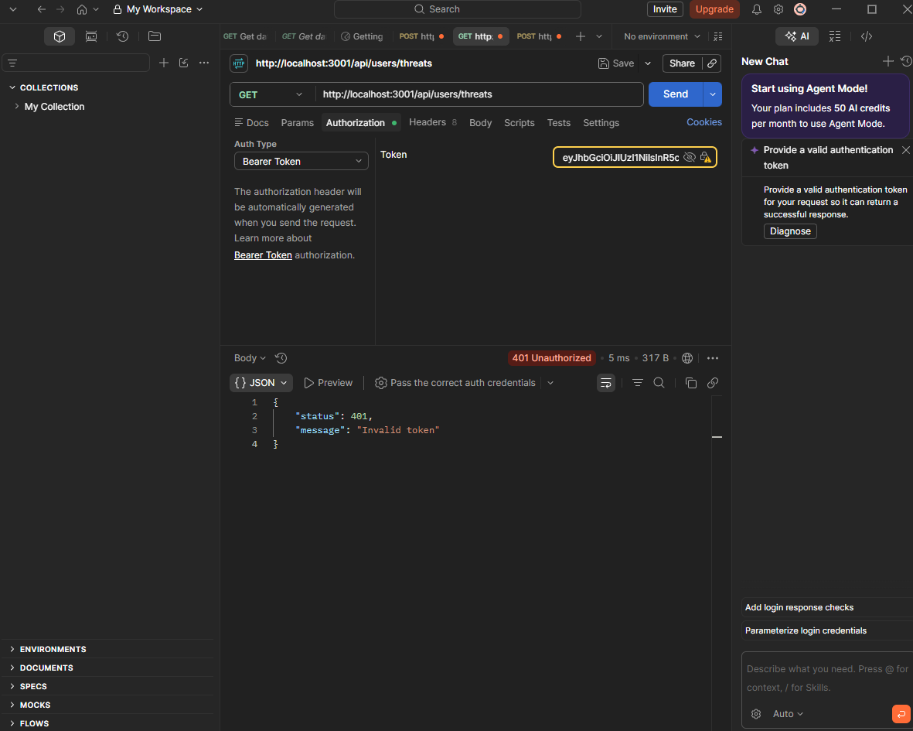

Finally. I tested the refresh token, which is used to keep the user logged in and generate a new access token. Before logout, the refresh token successfully returned 200 ok and generated a new access token. Then, after logging out, I reused the same refresh token by sending a request to the /api/users/auth/refresh endpoint. The server returned 401 with the message “invalid refresh token.” This shows that the refresh token can not be reused after logout.
